1. **Retrieve the entire contents of EMP table.**

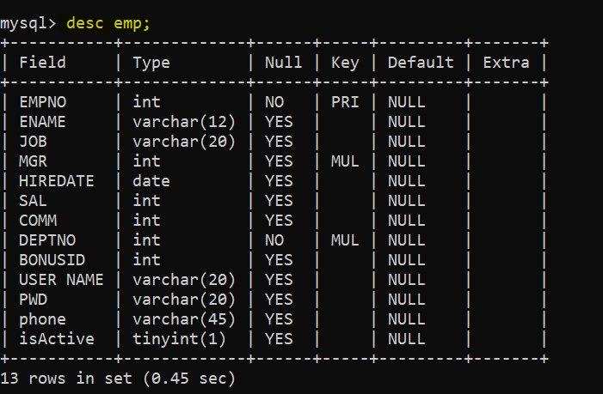

1. **Print the name of employees.**

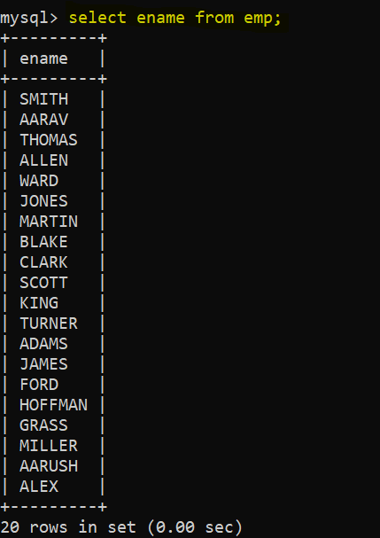

1. **Retrieve the list of names and jobs of employees.**

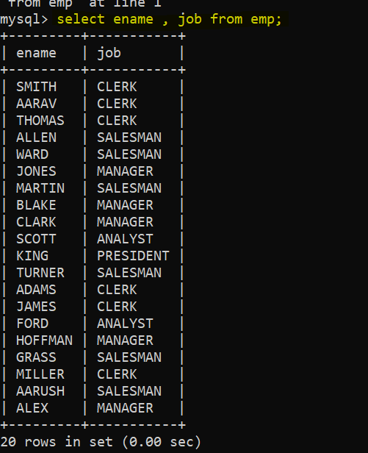

1. **List of various department available from dept table.**

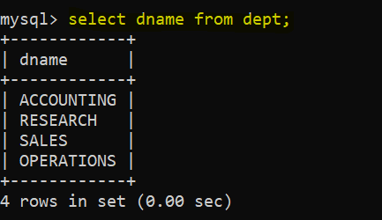

1. **List all information about the Employees of the EMP table.**

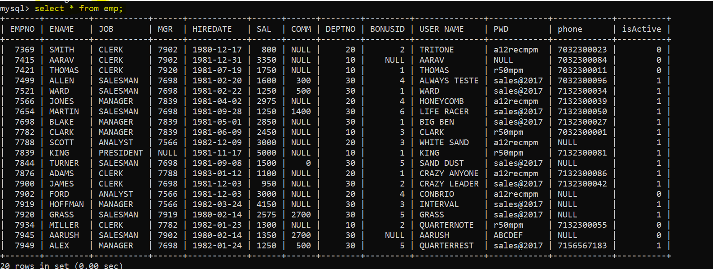

1. **Show the information of the Department table.**

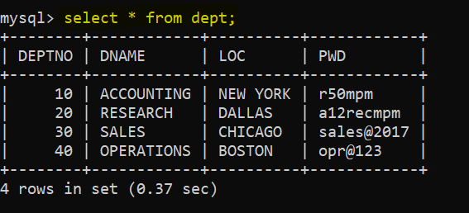

1. **Display the contents of the column Empno, Ename as Employee Name and Sal from the Emp table.**

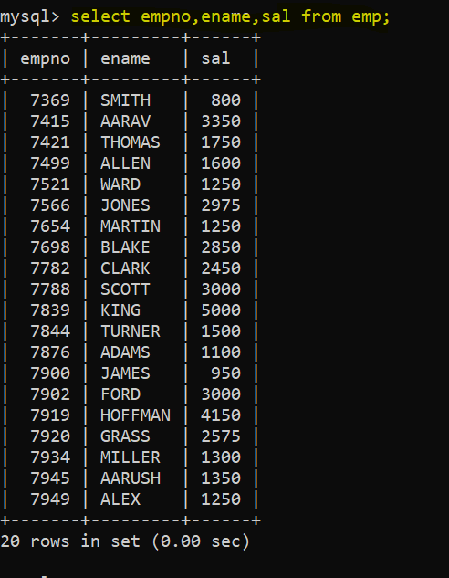

**8.Display the Job the location as “Location” and names of all the departments as “Department Names”.**

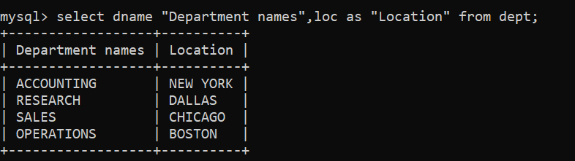

**9.List the different Managers Codes.**

**Select distinct mgr from emp where job =’manager’;**

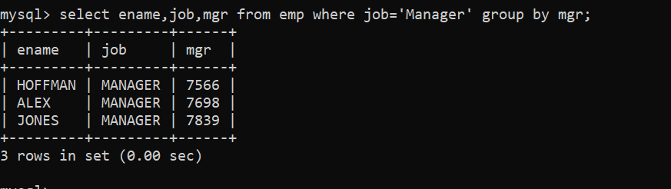

**10.Write a query, which cob, Comm and Ename from the Emp table with Customized column headings.**

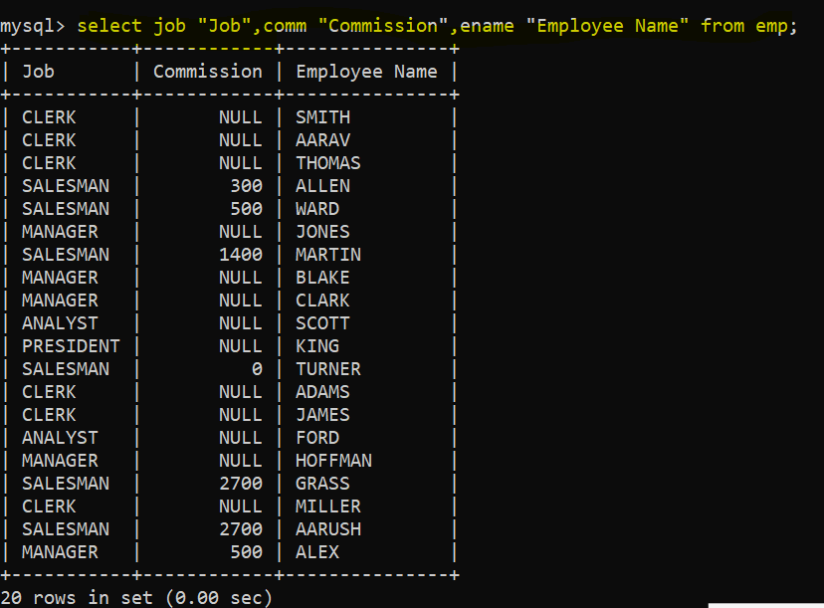

**11.Write the query which concatenate the Emp No, Name and Mgr Code. Display output with spaces in the columns.**

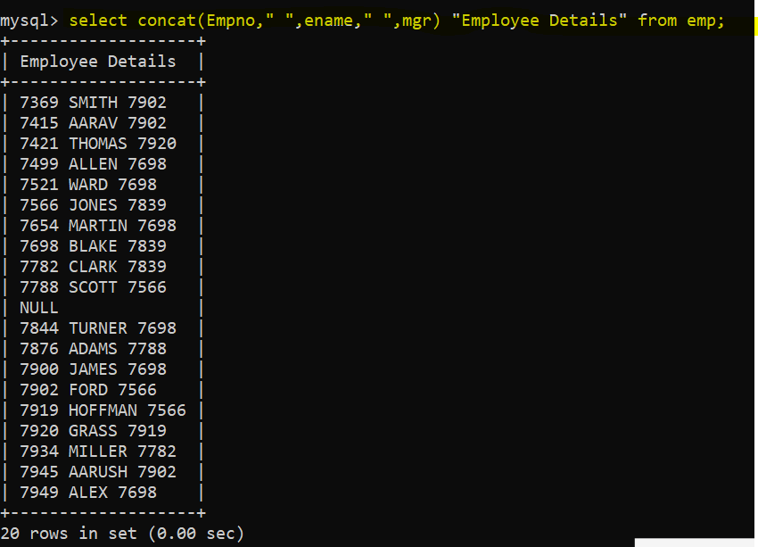

**12.Create a query to display all the data from the EMP table, separate each column by a comma.**

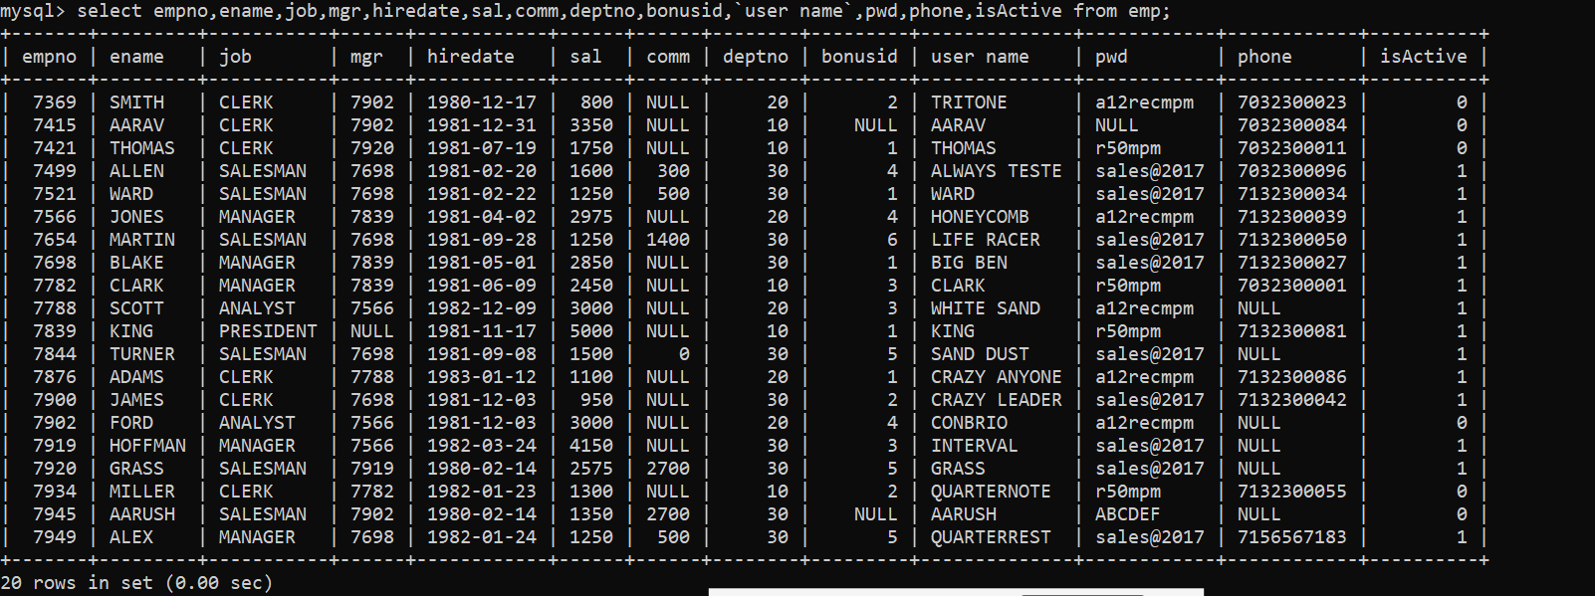

**13.Modify the above query to add a column that will subtract the Old Salary from the New Salary.**

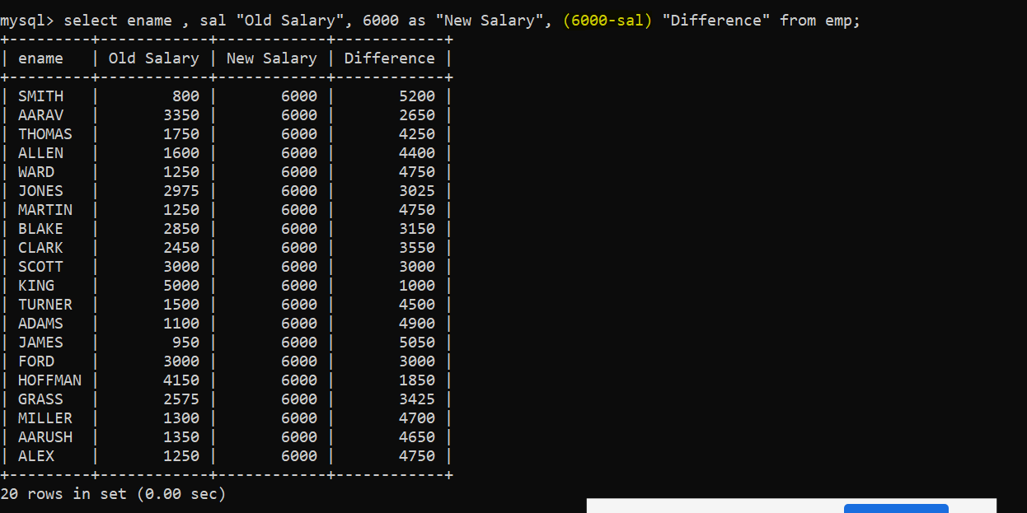

**14.Write a query that produces the following for each employee as-**

**<employee name> earns <salary> monthly, but wants salary <3 times salary>. Label the columns Dream Salaries.**

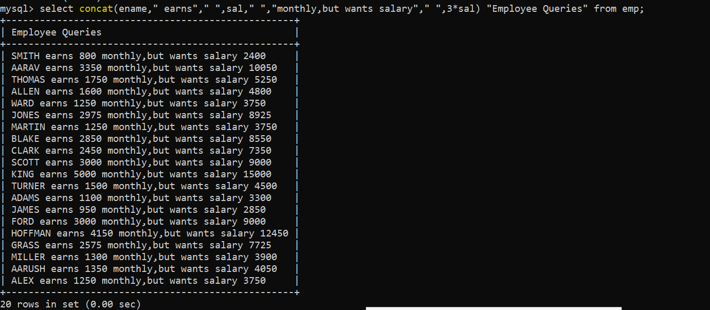

1. **Display different types of positions available in the Company.**

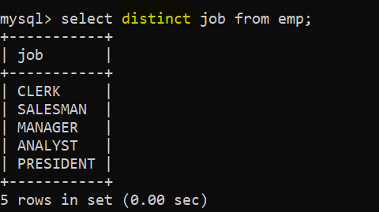

1. **Using the sales table, you need to report the following**
   1. **Appropriate column heading should be given for all the columns.**

